一、概述
适用于以油为介质的管路系统用焊接式管接头。公称压力为31.5MPa，工作温度为-25～+80℃。
焊接式端直通管接头、焊接式端直通长管接头、焊接式直通管接头、焊接式直角管接头，焊接式四通管接头，焊接式隔壁直通管接头、焊接式隔壁直角管接头、焊接式分管管接头、焊接式铰接管接头的型式和尺寸按图1～图10 和表1的规定。
二、结构形式
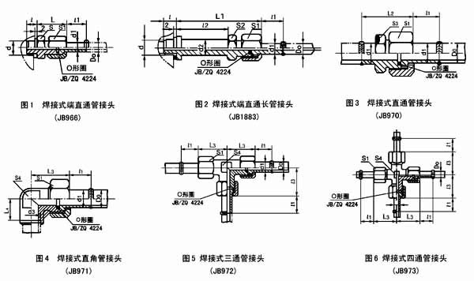
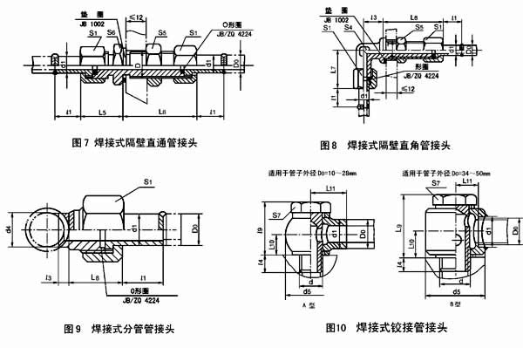
三、外形尺寸
管子直径Do | 公称通径DN | d | d1 | d2 | d3 | d4(H12/h12) | d5 | D+0.6/+0.44 | l | l1 | l2
6 | 3 | M10X1 | 7.5 | 10 | 6.5 | 7 |  | 12 | 8 | 14 | 32
10 | 6 | M10X1 | 11 | 10 | 10.5 | 11 | 22 | 16 | 8 | 16.5 | 35
10 | 6 | M14X1.5 | 11 | 14 |  |  |  |  | 12 | 16.5 | 35
14 | 8 | M14X1.5 | 16 | 14 | 14.5 | 16 | 28 | 22 | 12 | 19 | 43
14 | 8 | M18X1.5 | 16 | 19 |  |  |  |  | 12 | 21 | 43
18 | 10 | M18X1.5 | 19 | 19 | 18.5 | 19 | 36 | 27 | 12 | 21 | 45
18 | 10 | M22X1.5 | 19 | 24 |  |  |  |  | 14 | 21 | 45
22 | 15 | M22X1.5 | 22 | 24 | 22.5 | 22 | 46 | 30 | 14 | 21 | 48
22 | 15 | M27X2 | 22 | 28 |  |  |  |  | 16 | 21 | 48
28 | 20 | M27X2 | 28 | 28 | 28.5 | 28 | 56 | 36 | 16 | 24 | 54
28 | 20 | M33X2 | 28 | 34 |  |  |  |  | 16 | 24 | 54
34 | 25 | M33X2 | 34 | 34 | 34.5 | 34 | 64 | 42 | 16 | 26 | 65
34 | 25 | M42X2 | 34 | 44 |  |  |  |  | 18 | 26 | 65
42 | 32 | M42X2 | 42 | 44 | 42.5 | 42 | 78 | 52 | 18 | 28 | 72
42 | 32 | M48X2 | 42 | 50 |  |  |  |  | 20 | 28 | 72
50 | 40 | M48X2 | 50 | 50 | 50.5 | 50 | 90 | 60 | 20 | 30 | 78

管子直径Do | 公称通径DN | l3 | l4 | L | L1 | L2 | L3 | L4 | L5 | L6 | L7 | L8 | L9 | L10 | L11
6 | 3 | 3 |  | 22 | 54 | 30 | 24 | 12 | 22 | 41 | 26 | 20
10 | 6 | 4 | 8 | 24.5 | 59.5 | 32.5 | 28.5 | 15 | 25.5 | 44.5 | 30.5 | 21.5 | 23 | 8.5 | 15
10 | 6 |  |  | 25.5 | 60.5
14 | 8 | 5 | 10 | 29 | 72 | 41 | 35 | 20 | 29 | 49 | 38 | 27 | 29 | 11 | 20
14 | 8 |  |  | 29 | 72
18 | 10 | 7 | 12 | 33 | 78 | 45 | 39 | 22 | 33 | 51 | 42 | 29 | 34 | 13 | 25
18 | 10 |  |  | 33 | 78
22 | 15 | 8 | 14 | 34 | 82 | 48 | 43 | 26 | 35 | 55 | 46 | 30 | 43 | 17 | 30
22 | 15 |  |  | 35 | 83
28 | 20 | 9 | 15 | 37 | 91 | 53 | 48 | 30 | 39 | 57 | 51 | 32 | 50 | 20 | 35
28 | 20 |  |  | 39 | 93
34 | 25 | 10 | 16 | 46 | 111 | 62 | 57 | 36 | 46 | 62 | 61 | 37 | 66 | 27 | 24
34 | 25 |  |  | 48 | 113
42 | 32 | 12 | 17 | 50 | 122 | 68 | 64 | 40 | 48 | 68 | 68 | 39 | 82 | 34 | 30
42 | 32 |  |  | 52 | 124
50 | 40 | 15 | 19 | 56 | 134 | 76 | 74 | 48 | 54 | 74 | 78 | 43 | 94 | 38 | 33

管子外径Do | 公称通径DN | S | S1 | S2 | S3 | S4 | S5 | S6 | S7 | O型圈JB/ZQ4224 | 垫圈
6 | 3 | 17 | 14 | 14 | 14 | 10 | 17 | 17 |  | 8X1.9 | 10
10 | 6 | 17 | 19 | 17 | 17 | 14 | 22 | 22 | 17 | 11X1.9 | 10
10 | 6 | 19 | 19 | 19 |  |  |  |  |  | 11X1.9 | 14
14 | 8 | 22 | 27 | 22 | 22 | 19 | 30 | 27 | 19 | 16X1.9 | 14
14 | 8 | 24 | 27 | 24 |  |  |  |  |  | 16X1.9 | 18
18 | 10 | 27 | 32 | 27 | 27 | 24 | 36 | 32 | 24 | 20X2.4 | 18
18 | 10 | 30 | 32 | 30 |  |  |  |  |  | 20X2.4 | 22
22 | 15 | 30 | 36 | 30 | 30 | 27 | 41 | 36 | 30 | 24X2.4 | 22
22 | 15 | 36 | 36 |  |  |  |  |  |  | 24X2.4 | 27
28 | 20 | 36 | 41 | 36 | 36 | 32 | 50 | 41 | 36 | 30X3.1 | 27
28 | 20 | 41 | 41 | 41 |  |  |  |  |  | 30X3.1 | 33
34 | 25 | 46 | 50 | 46 | 46 | 41 | 55 | 50 | 41 | 35X3.1 | 33
34 | 25 | 55 | 50 | 55 |  |  |  |  |  | 35X3.1 | 42
42 | 32 | 55 | 60 | 55 | 55 | 50 | 65 | 60 | 55 | 40X3.1 | 42
42 | 32 | 60 | 60 | 60 |  |  |  |  |  | 40X3.1 | 48
50 | 40 | 65 | 70 | 65 | 65 | 60 | 70 | 70 | 60 | 45X3.1 | 48

管子外径Do | 公称通径DN | 重量kg
管子外径Do | 公称通径DN | JB966-77 | JB1883-77 | JB970-77 | JB971-77 | JB972-77 | JB973-77 | JB974-77 | JB975-77 | JB977-77 | JN978-77
6 | 3 | 0.039 | 0.052 | 0.028 | 0.032 | 0.064 | 0.087 | 0.077 | 0.096 | 0.021
10 | 6 | 0.060 | 0.082 | 0.055 | 0.068 | 0.145 | 0.190 | 0.158 | 0.183 | 0.046 | 0.059
10 | 6 | 0.071 | 0.103
14 | 8 | 0.143 | 0.210 | 0.150 | 0.160 | 0.370 | 0.5 | 0.344 | 0.366 | 0.12 | 0.103
14 | 8 | 0.155 | 0.235
18 | 10 | 0.199 | 0.325 | 0.190 | 0.250 | 0.510 | 0.680 | 0.505 | 0.53 | 0.160 | 0.190
18 | 10 | 0.236 | 0.356
22 | 15 | 0.270 | 0.436 | 0.240 | 0.310 | 0.650 | 0.880 | 0.6 | 0.67 | 0.210 | 0.342
22 | 15 | 0.320 | 0.480
28 | 20 | 0.390 | 0.620 | 0.370 | 0.470 | 0.920 | 1.250 | 0.95 | 1.02 | 0.280 | 0.660
28 | 20 | 0.450 | 0.640
34 | 25 | 0.600 | 1.000 | 0.630 | 0.760 | 1.530 | 2.180 | 1.68 | 1.97 | 0.470 | 1.320
34 | 25 | 0.850 | 1.224
42 | 32 | 1.060 | 1.624 | 1.050 | 1.220 | 2.400 | 3.800 | 2.03 | 2.53 | 0.670 | 2.140
42 | , ,  32 | 1.170 | 1.730
50 | 40 | 1.670 | 2.430 | 1.570 | 2.050 | 3.9 | 5.300 | 3.34 | 3.84 | 1.050 | 3.330

四、标记说明
a、管子外径D0为18mm、螺纹直径d为22mm、螺距为1.5mm的焊接式端直通管接头：
管接头 18-M22 × 1.5 JB/966-77
b、管子外径D0为18mm、螺纹直径d为22mm、螺距为1.5mm的焊接式端直通长管接头：
管接头 18-M22×1.5 JB/1883-77
c、管子外径D0为28mm的焊接式端直通管接头：
管接头 28 JB970-77
d、管子外径D0为28mm的焊接式直角管接头：
管接头 28 JB971-77
e、管子外径D0为18mm的焊接式三通管接头：
管接头 18 JB972-77
f、管子外径D0为18mm的焊接式四通管接头：
管接头 18 JB973-77
g、管子外径D0为28mm的焊接式隔壁直通管接头：
管接头 28 JB974-77
h、管子外径D0为28mm的焊接式隔壁直通角管接头：
管接头 28 JB975-77
i、管子外径D0为28mm的焊接式分管管接头：
管接头 28 JB977-77
j、管子外径D0为28mm的A型焊接式铰管接头：
管接头 28A JB978-77

